

بــــــــــــسم اللـــــــــــه الـــــــــــــــــــرحمان الــــــــــــــــــرحيم

HERITAGE GLOBAL ACADEMY

2, Ola Iya Close, Off Okiki Street, Isawo Road, Owutu, Agric-Ikorodu, Lagos

2ND CA 1st Term Examinations 2022/2023 Session Date: November, 2023

Subject: History JSS3

ANSWER ALL QUESTIONS 40 minutes

1. The Assembly consists of the House of Representatives and the _______
2. What are the three most common languages spoken in Nigeria?
3. The name Nigeria was coined from Niger and area byLady _____________
4. The first storey building in Nigeria was built in _______
5. Nigeria became a Republic Nation in the year ________
6. The three(3) major ethnic groups in Nigeria are ______
7. Nigeria is divided into _______states
8. The first President in Nigeria was Dr. _______
9. Laws for the country are made by the National ________
10. Nigeria shared boarder with Benin to the ________
11. The first Military Head of State in Nigeria was _______
12. The correct colour combination of the Nigeria flag Green, ________and _______
13. The Nigeria Civil War started in the year 196___
14. The country Nigeria is is in the ________ of Africa
15. The longest river in Africa is ________River

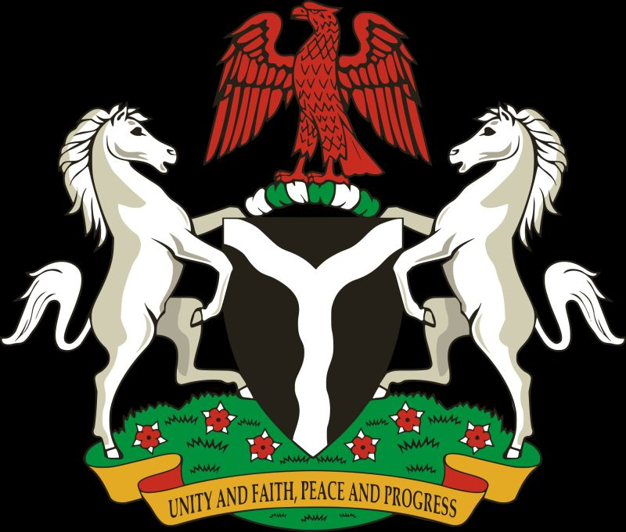

1. The two white horses on the Nigerian Coat of Arms stands for _______
2. Nigeria became an independent Nation on ________
3. The Nigerian #100 note shows Chief ______________
4. The tier government nearest to the people is the ________
5. Lord ________introduced indirect rule in Nigeria.
6. A nation consists of people with common ancestry, Common _________ and a shared set of values.
7. There are ________Geo-Political Zones in Nigeria.

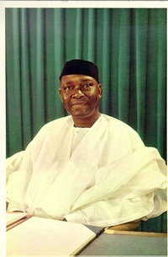

1. The image above is that Dr. ____________
2. The history of Nigeria can be traced to the earliest inhabitants whose remains date from at least 13,000 BC through early civilizations such as the Nok culture which began around ___________BC

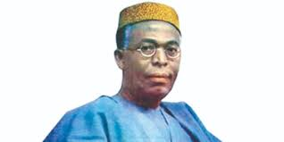

1. The man above is Chief ___________
2. An empire in the old western region of Nigeria is the _________empire but the cradle of Yoruba land is _____.
3. A kingdom in the old western region now south south is _______ kingdom.
4. Islam came into Nigeria through the ________ empire.
5. Older trade patterns and route was through the Trans-__________ route
6. Slave trade through Badagry mainly used _________ Ocean route

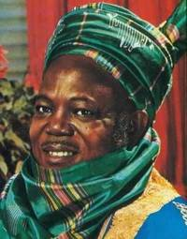

1. The man in the picture is Sir_________
2. The Igbos declared their independence from Nigeria in 1967 but was unsuccessful, they called their nation _______nation.
3. June 12 was set aside to remember Chief _______who won the presidential election in 1993 and was imprisoned and later died.
4. National Day in Nigeria is __________
5. The main currency of Nigeria is _________
6. The first ruler of Sokoto Caliphate is Usman_________
7. A person who works in archives is known as _______
8. Documents in archives are known as _______materials archival
9. The Igbos are located in the south ______geographical zone
10. Age grades and secret societies ruled ______(centralised / non centralised state)
11. Sultan is associated with ________tribe in Nigeria.
12. A __________(centralised state / non centralised state) is a state in Nigeria where power did not reside in the hand of one leader only.
13. List THREE empires in the old Western Africa beside Nigeria.
14. Trade in the old days across the Trans-Sahara was exchange of goods for ______(money / goods)
15. Mention THREE items used for trading in the West African empires.
16. List THREE record sites where history materials can be found.
17. The title of the ruler of Ile-Ife is called ______
18. The first culture to provide Iron Smelting Technology is ______
19. Benin Culture and _______culture have some similarities
20. Raw evidence of human actions that contains first hand information is known as _______
21. List TWO other items aside from clay used by NOK people.
22. The Nok culture was known for _________sculptures
23. The Nok culture is associated with the archaelogical findings at ______state
24. Ham village of **Nok** , where their sculptures were first discovered in 19____.
25. The Ife Civilization is most remarkable for its use of terra cotta and______ heads
26. The last ruler of the Ogiso dynasty in the Benin Empire was Oba Owo___

The first of three archaeological sites, called *Igbo ______*, was uncovered in 1938 by a local villager, who found the bronze works while digging beside his home.

1. What was the effect of the ascension of weak rulers to Benin throne?
2. List any three nationalists in Nigeria from 1922 to 1960.
3. State TWO benefits a university student studying history has.
4. Name one prominent person in the following
5. Songhai Empire -
6. Mali Empire -